

**MATHEMATICS  
APPLICATIONS**

**Test 3 – Recurrence Relationships**

**Chapter 4**

**Semester 1 2017**

# 

**Section One - Calculator Free**

Time allowed for this section

Working time for this section: 25 minutes

Marks available: 21 marks

## Material required/recommended for this section

##### To be provided by the supervisor

This Question/Answer booklet

Formula sheet

##### To be provided by the candidate

Standard items: pens, pencils, pencil sharpener, eraser, correction fluid, ruler, highlighters

Special items: Nil

## Important note to candidates

No other items may be used in this section of the examination. It is **your** responsibility to ensure that you do not have any unauthorised notes or other items of a non-personal nature in the examination room. If you have any unauthorised material with you, hand it to the supervisor **before** reading any further.

1. (6 marks)  
     
   The terms of a sequence are shown in the graph below.

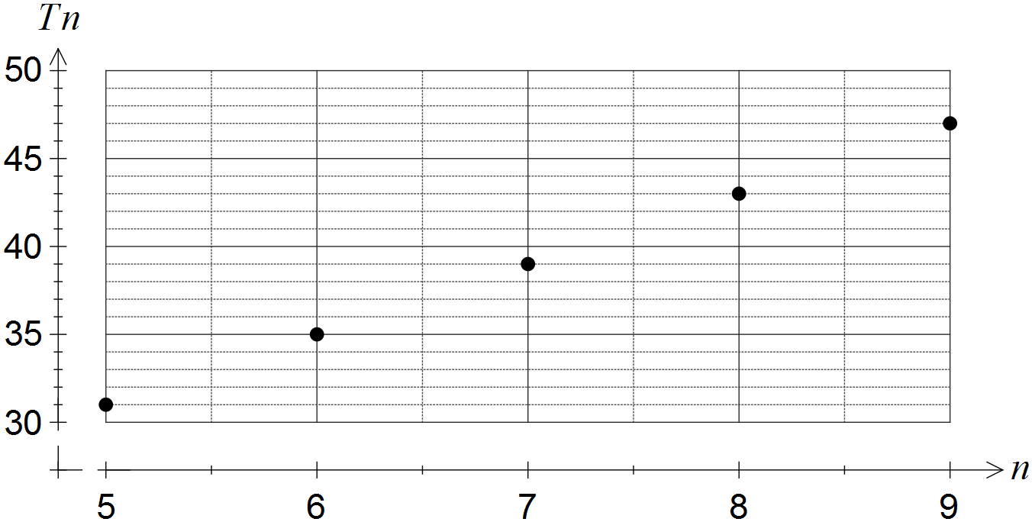

(a) Choose the best description of the sequence from geometric, arithmetic or neither, explaining your choice. [2]

(b) Determine

(i) . [1]

(ii) . [1]

(c) Determine the **recursive rule** for this sequence. [2]

1. (9 marks)
   1. A sequence is defined by  , where **.**
      1. Determinethe next two terms of the sequence.[2]
      2. State a rule for the nth term of this sequence.[1]
      3. Determine  [2]
   2. The first-order recurrence relation  was used with  to calculate  and . Determine the values of *b, c* and **.** [4]
2. (5 marks)
3. Some consecutive terms of an arithmetic sequence are shown in the table below.

|  |  |  |  |  |
| --- | --- | --- | --- | --- |
| n | 5 | 6 | 7 | 8 |
|  | 22.5 | 24.8 | 27.1 | 29.4 |

(i) Determine the ninth term of this sequence. (2 marks)

(ii) Determine the first term of the sequence. (1 marks)

(iii) State a difference equation for this sequence. (2 marks)

**End of Section One**